DAY 3 – 11.04.2024

OUTPUT SCREENSHOTS

1. DIVISIBLE BY 7

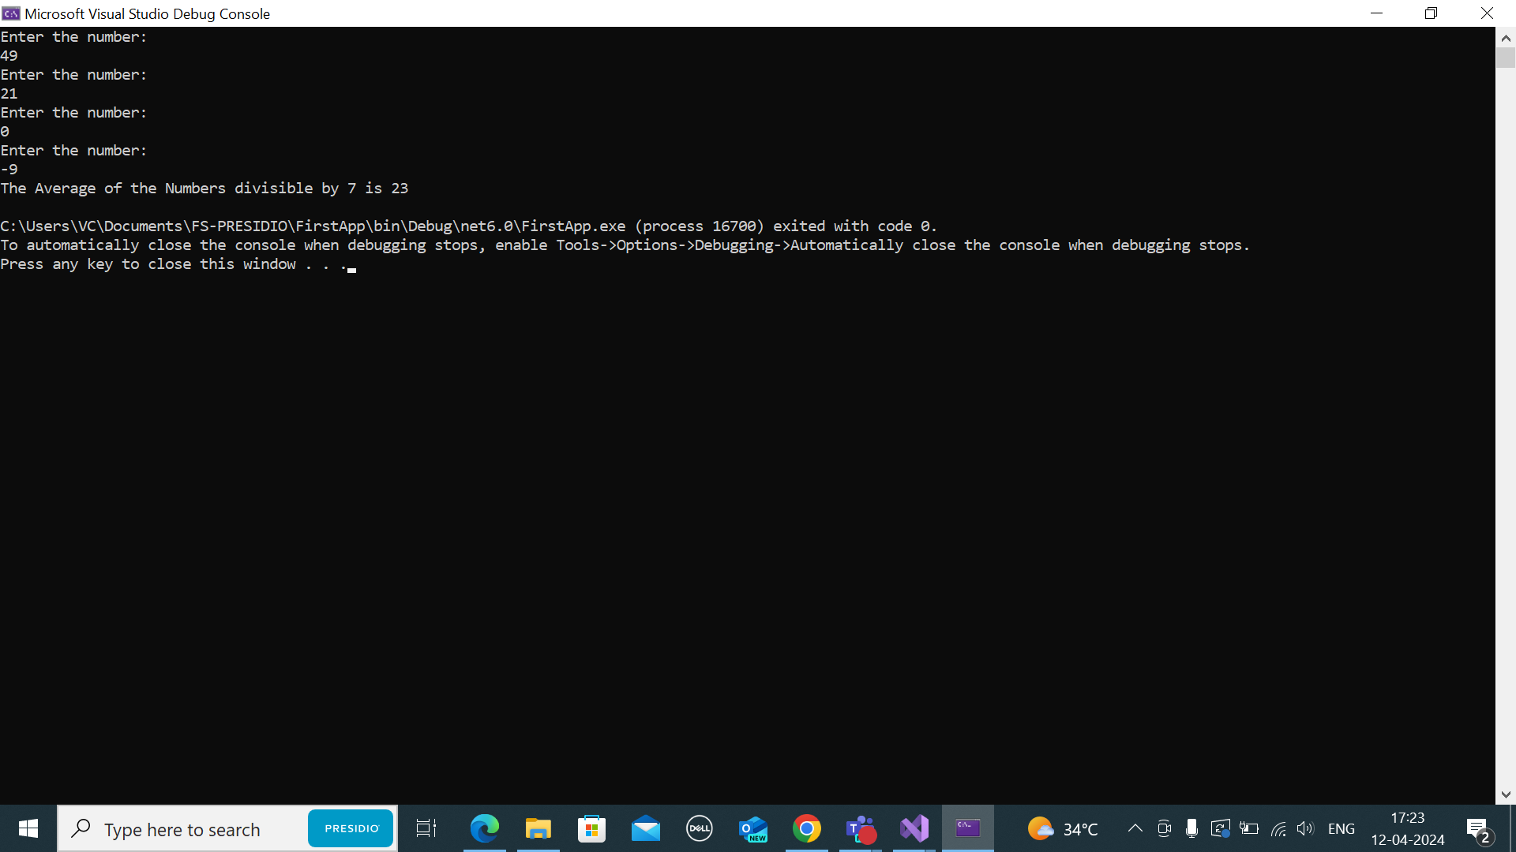

1. GREATEST OF ALL NUMBERS PROVIDED

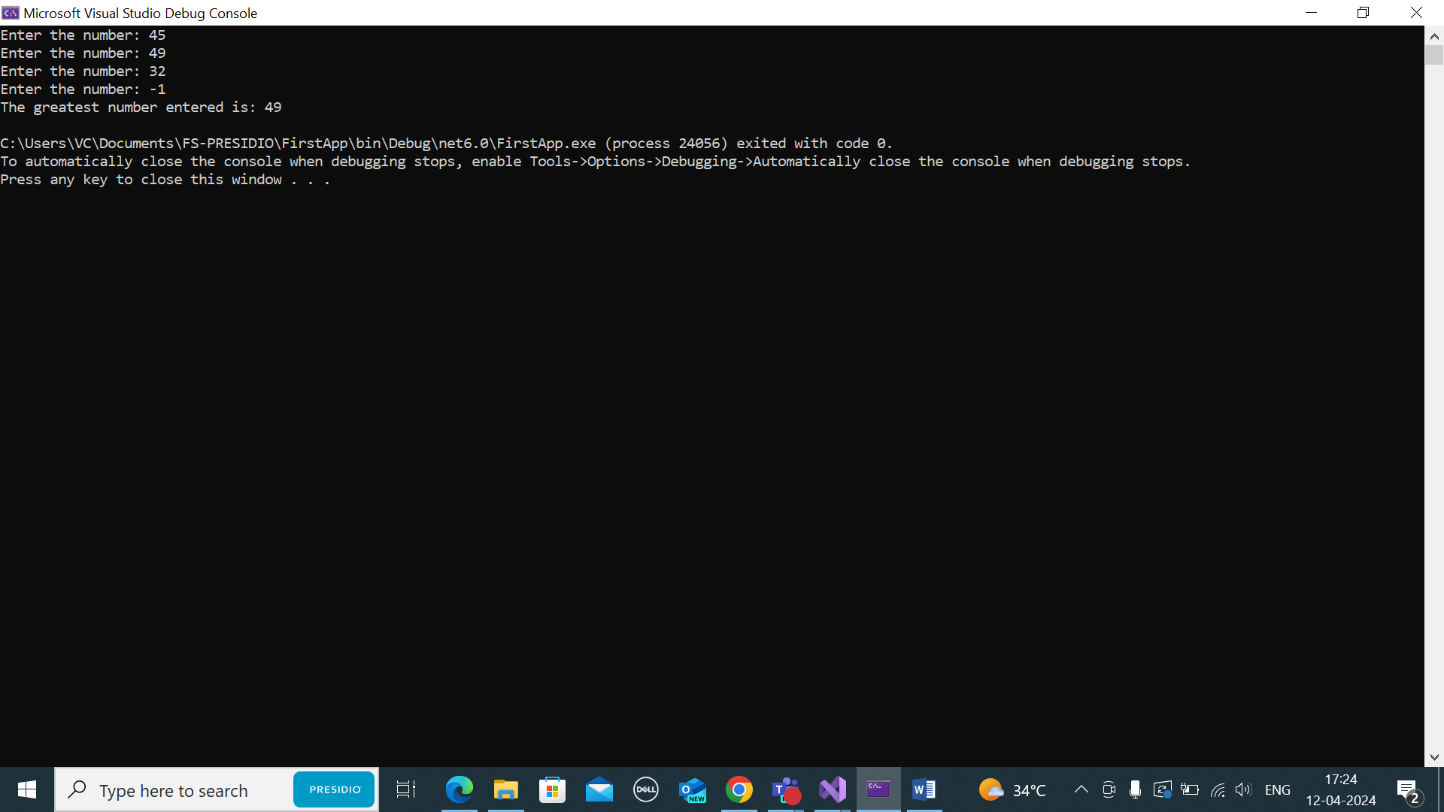

1. MATHEMATICAL OPERATIONS

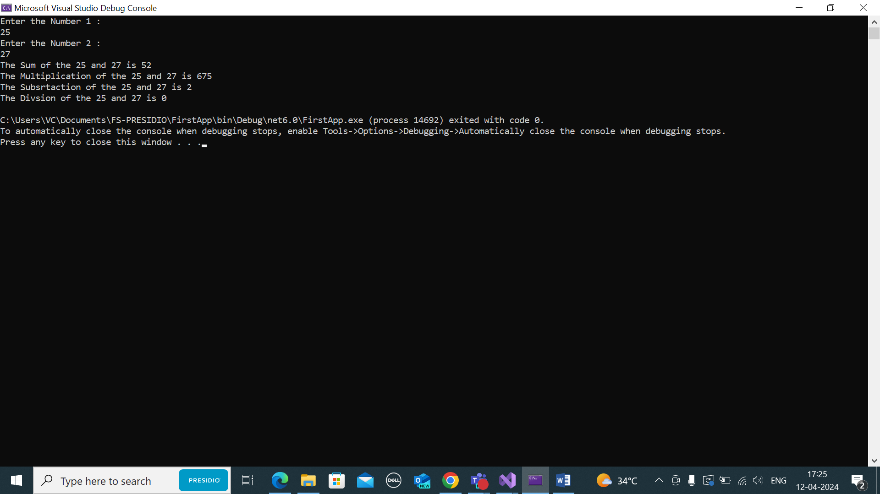

1. USERNAME LENGTH

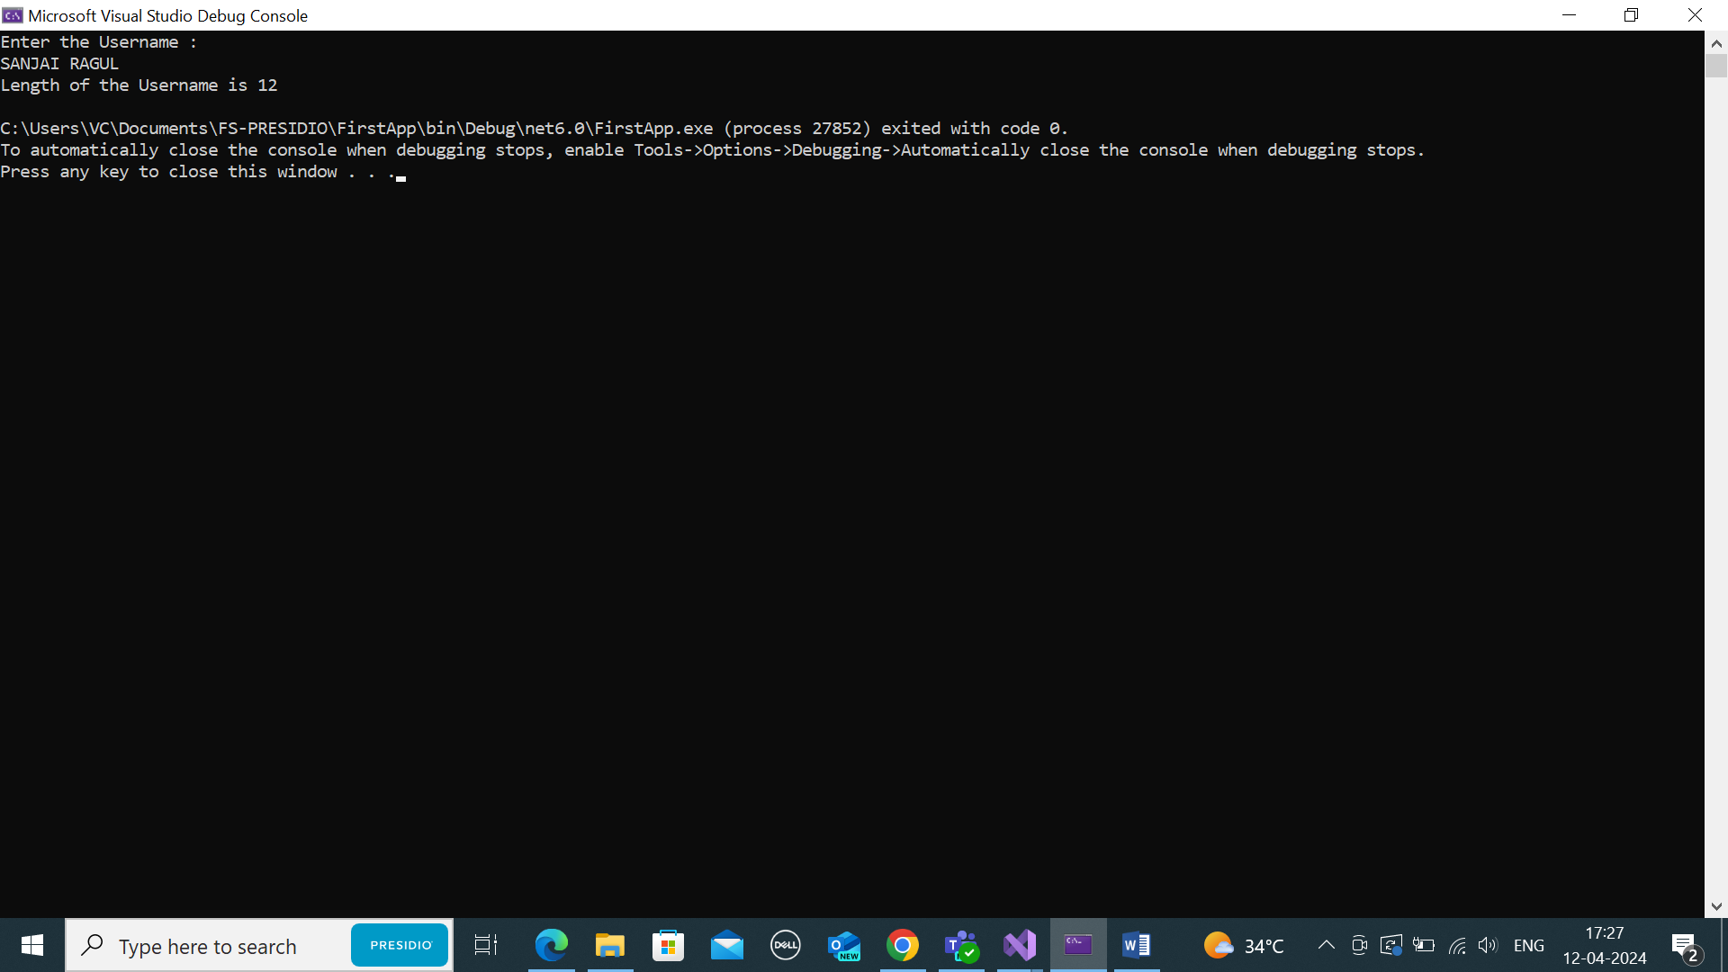

1. VALID CREDENTIALS (USERNAME AND PASSWORD)

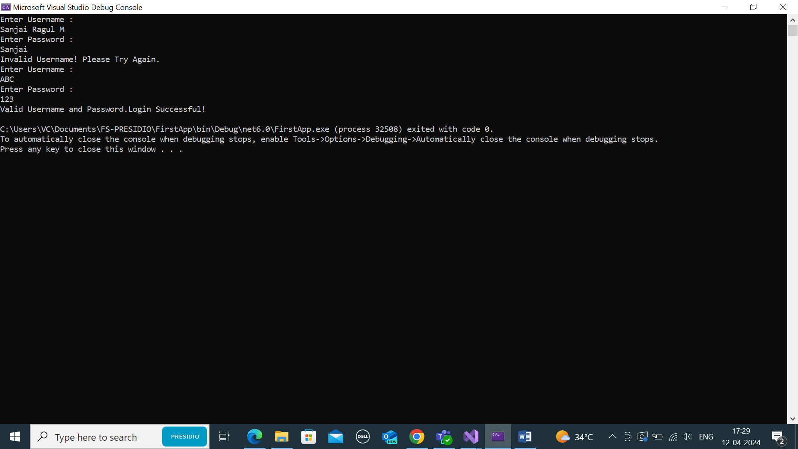

1. MINIMUM VOWELS REPEATING

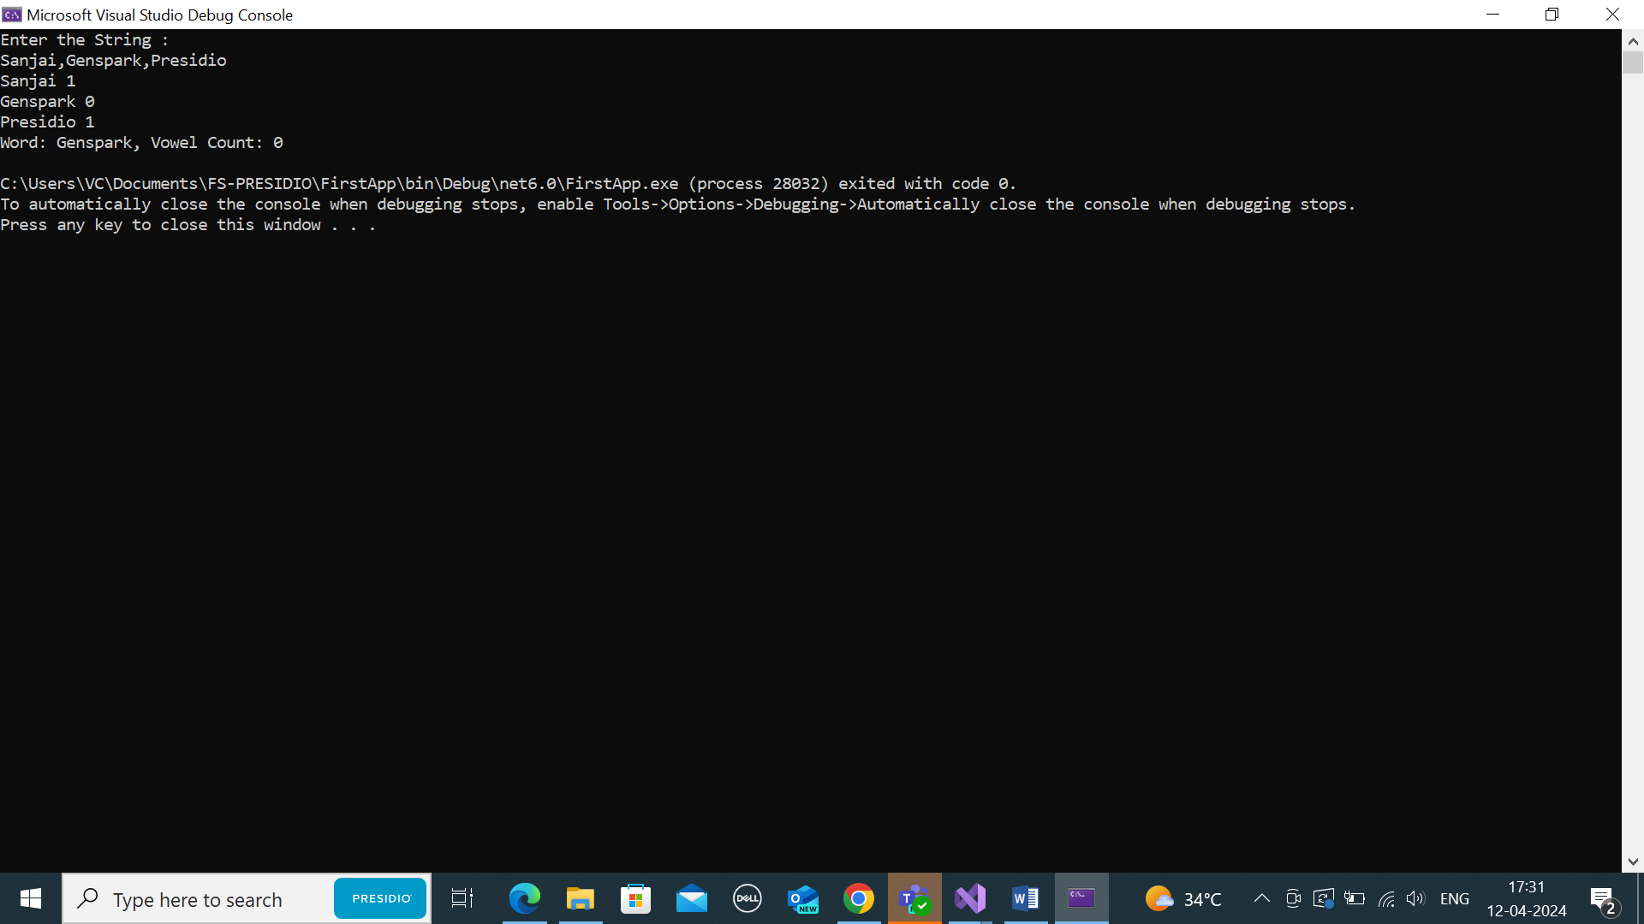

CODILITY ANSWER SUBMISSION SCREENSHOTS

